God’s Plan for Me Lesson 6: Baptism Into Christ

Baptism is part of the gospel, or good news, about Christ. In fact, the gospel message is not complete without it (Mark 16:15-16; Acts 8:35-36). If we believe the whole gospel of Christ, we will believe what it teaches about baptism.

The Bible teaches about four baptisms: the baptism of John the Baptist (Luke 3:3), the baptism of fire (Matthew 3:11), the baptism of the Holy Spirit (Matthew 3:11), and the baptism of the Great Commission (Matthew 28:19-20). Today there is only one baptism (Ephesians 4:5). So, which of the four is the one baptism of the New Testament?

The baptism of John the Baptist was given before Jesus worked and died. It was given to make people ready for Him. It was not given in Jesus’ name. When the New Testament covenant began in Acts 2, the baptism of John ended. It had done what it was given to do (read Acts 19:3-5).

The baptism of fire will be given by Christ after the end of the world, when evil people are sent to their eternal punishment. (Matthew 3:11-12; Revelation 21:8.)

The baptism of the Holy Spirit was promised by Jesus in Matthew 3:11 and was only given by Him to the apostles (Acts 2) and to Cornelius, the first Gentile to become a Christian (Acts 10).

The one baptism of the New Testament, the one which is given for today, is the baptism of the Great Commission. This baptism was commanded by Christ and is to be obeyed by all people until the end of time (Matthew 28:18-20). Let us study what the New Testament says about the one baptism.

How?

Baptism is doing something. The Bible says that we are buried when we are baptized. In Romans 6:4 and Colossians 2:12, baptism is called a burial. When something is buried, it is put under the ground. When we are buried in baptism, we are put under the water. We are not buried by having water sprinkled or poured on us, as some people teach. That would not be a burial.

We are then raised with Christ to a new life. As the apostle Paul said, “Therefore we have been buried with Him through baptism into death, so that as Christ was raised from the dead through the glory of the Father, so we too might walk in newness of life. For if we have become united with him in the likeness of his death, certainly we shall also be in the likeness of His resurrection (Romans 6:4-5). Just as Christ was buried in the tomb and was then raised from it to live again, so we are buried by baptism with water all around us and raised from the water to live a new life. We cannot be raised from a few drops of water. In Colossians 2:12, Paul referred to, “…having been buried with Him in baptism, in which you were also raised up with Him through faith in the working of God, who raised Him from the dead.”

The baptism of John the Baptist was not the one baptism of the New Testament, but it was water baptism, and John baptized (immersed) where there was much water (John 3:23). It takes much water to immerse a person (Acts 8:36-39). The baptism that Christ commands of every person is always immersion, for that was the original meaning of the word “baptize.”

Why?

The New Testament teaches that we must be immersed into Christ to be saved. The reason we are saved when we are baptized is not because we are good enough to be saved. No amount of good behavior can cause us to earn or deserve our salvation. Instead, we are saved because Jesus Christ was good. He lived without sinning and then gave His life on the cross so that His blood could cleanse us from our sins. When we believe and obey Him, His blood cleanses us from sin. We must obey Him to be cleansed, but it is not our obeying that cleanses us. It is Christ’s blood that cleans and saves.

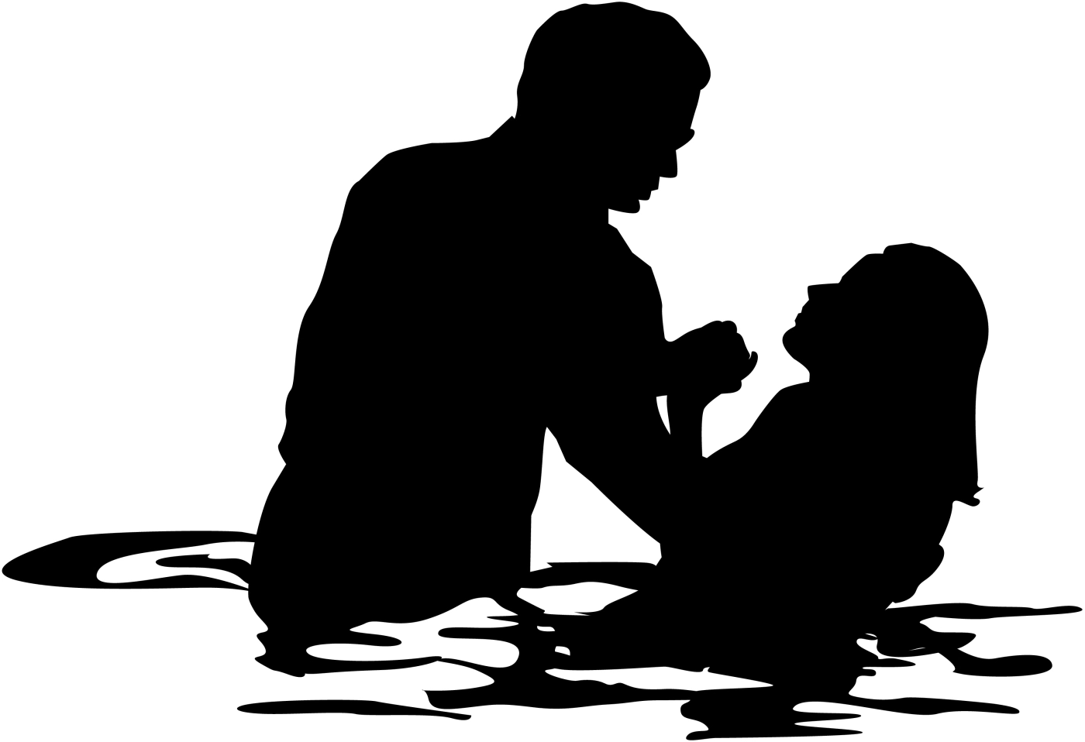
In our lesson about faith in Christ, we studied about baptism, and we saw that we must both believe and obey to gain the salvation Christ offers. We will study some of the same verses in this lesson because they are important.

Peter said to them, "Repent, and each of you be baptized in the name of Jesus Christ for the forgiveness of your sins; and you will receive the gift of the Holy Spirit” (Acts 2:38). “For the forgiveness of your sins" means that our sins are forgiven or cancelled. Some people say that our sins can be forgiven even if we are not baptized. If that were true, then we would not need to repent, or turn away from sin either. But this verse says that both baptism and repentance are necessary for sins to be forgiven. The words “for the forgiveness of sins” are also found in Matthew 26:28, with reference to the blood of Jesus. His blood was shed, “…for the forgiveness of sins.” And, of course, we must have Christ’s blood to be saved.

In Romans 6:3-4, Paul says that we are “baptized into His death” and now “walk in newness of life.” When we are baptized into Christ’s death, we are cleansed by His blood (John 19:33-34, Hebrews 9:22, and Ephesians 1:7). Romans 6:3 clearly and simply teaches that baptism is the way we come into the death of Christ. Those who have not been baptized have not come into His death and have not had their sins forgiven and do not live the new life. As Paul wrote, “For all of you who were baptized into Christ have clothed yourselves with Christ” (Galatians 3:27).

In John 3:3, Jesus teaches that we enter the kingdom of God when we are “born of water and the Spirit.” We know that two things happen when a baby is born: the baby is conceived and then is delivered. The new birth happens the same way. We are conceived by the Holy Spirit through the word of God (John 16:7-13 and 1 Peter 1:23). Then we are delivered into Christ through the one baptism. When a baby is born, he passes from his mother’s womb, where he has had water all around him (John 3:4), and into the open world. When we are baptized, we have water all around us, and then we are “born of water” into a new life where we are saved in Christ (Romans 6:4).

We are baptized in response to hearing the word of God. As the Bible explains in Acts 2:41, “So then, those who had received His word were baptized” (Acts 2:41). This verse teaches that the people were baptized when they received God’s word. Those who rejected the word of God were not baptized. As Jesus explained, “He who rejects Me and does not receive My sayings, has one who judges him; the word I spoke is what will judge him at the last day” (John 12:48). We cannot be saved without being baptized, because we cannot be saved if we reject the word of Christ. Other verses which teach that we must be baptized to be saved are Mark 16:16, Acts 10:48, 22:16, and 1 Peter 3:20-21.

Who?

The New Testament teaches that believers who repent, or turn from their sins, are to obey the one baptism. There is not a single command or example for baptizing babies in the New Testament. Babies have no sins, because sin is lawlessness (1 John 3:4), and babies have not broken God’s law. Laws are not given to babies, and no one expects them to obey. In fact, Jesus said that they are innocent and pure (Matthew 18:3; 19:14). They do not need to be saved, because they are not unsaved – they are safe!

Further, when Jesus explained baptism, he taught that those who needed to be baptized were to be taught and that they were to believe (Matthew 28:19-20, Mark 16:15-16). Babies should not be baptized because they cannot be taught the gospel, and they cannot believe it. Those who baptize babies do it without the authority of Christ. Those who are baptized must also repent. As Peter said, “Repent and each of you be baptized" (Acts 2:38). Babies cannot repent; therefore, they cannot be baptized.

In summary, the Bible teaches that baptism is a crucial part of God’s plan of salvation. In Samaria, “They were being baptized men and women alike (Acts 8:12). Concerning Peter’s message to Cornelius, the Bible says that, “He ordered them to be baptized (Acts 10:48). When Paul preached in Corinth, the Bible explains that, “Many of the Corinthians when they heard were believing and being baptized” (Acts 18:8).

In 1 Peter 3:21, Peter explains the importance of baptism by comparing it to the ark that saved Noah. He said, “Corresponding to that, baptism now saves you—not the removal of dirt from the flesh, but an appeal to God for a good conscience—through the resurrection of Jesus Christ.” Just as Noah obeyed God by building an ark, so also we obey God by being baptized (resulting in our salvation).

Have you been baptized (buried) in water “in the name of the Father, and of the Son, and of the Holy Spirit” (Matthew 28:19), so that your sins can be forgiven?

We hope this series of lessons has been a helpful guide in discovering God’s plan for your life.

True or False (write T or F in the blank):

___ 1. The gospel is complete without baptism.
___ 2. The baptism of John the Baptist can still be obeyed.
___ 3. We are baptized because we are already saved.
___ 4. Baptism requires being sprinkled with water.
___ 5. Jesus said that babies must be baptized.
___ 6. The one baptism requires water.
___ 7. We are baptized into Jesus’ death.
___ 8. The baptism of fire will come at the end of the world.
___ 9. Baptism does not save us.
___ 10. Baptism is the beginning of a new life.

Multiple Choice (write the letter in the blank):

___ 11. We are _____ with Christ in baptism (Colossians 2:12).
a - believing b - obeying c - buried
___ 12. We are baptized _____ (Acts 2:38).
a - to wash our bodies b - to show we are saved c - for the forgiveness of sins
___ 13. We are baptized into _____ (Galatians 3:27).
a - a church b - Christ c - Peter
___ 14. Matthew 28:19 teaches that we are to baptized in the name of _____.
a - Peter b - John the Baptist c - the Father, Son and the Holy Spirit
___ 15. Jesus said one must be born of _____ and the Spirit to enter the Kingdom of God (John 3:5).
a - blood b - water c - faith
___ 16. _____ gave the Great Commission in Matthew 28:18-20.
a - Peter b - Paul c - Jesus
___ 17. How many baptisms were in effect by the time Paul wrote Ephesians 4:5?
a - one b - three c - four
___ 18. After baptism we are raised with Christ to _____ (Romans 6:4-5).
a - continue our old life b - live a new life c - do whatever feels good to us
___ 19. When one is baptized, he is cleansed by the _____ (Ephesians 1:7).
a - water b - priest c - blood of Jesus
___ 20. Jesus said people would be judged in the last day by _____ (John 12:48).
a - His word b - our heart c - a priest or minister

Name: _______________________________ Address: ____________________________ City: _______________ State: ____ ZIP: ________

Four Lakes Church of Christ • 302 Acewood Boulevard • Madison, WI 53714-2511 • www.fourlakescoc.org • fourlakeschurch@gmail.com

